Information for Sinks
Product Name: Top Mount Sink
Model Number:
- FZ-SN50-S43T
- FZ-SN50-S53T
- FZ-SN50-S63T
- FZ-SN50-S73T
- FZ-SN50-D39T
- FZ-SN50-D50T
Country of Origin: Made in China
Warranty Coverage:
NA
Promotions Applicable:
NA









Icons to include:
Sink Depth
Waste
SUS 304
Rounded Corner
X-Shaped Drainer
Anti Condensation
Noise Reduction Pad

Introduction:
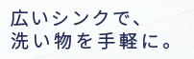
Keep the washing within your sink

Fujioh’s handmade stainless steel sinks come with environmentally friendly noise reduction pads and condensation-resistant coating, equipping your kitchen with a quieter and moisture-resistant sink. With X-shaped drain lines and rounded corners, the sink can be easily cleaned and maintained.
Using 1.2mm-thick material, the durable sinks have deeper depth, allowing you to fit bigger pots and pans in the sink bowl, reducing water splashing to a minimum.
Accessories:
TBA

Advanced Functions:
01/ Condensation-resistant Coating and Noise Reduction Pads
· Reduce moisture
· Quieter wash
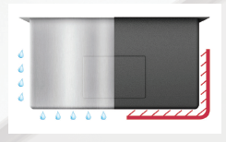

02/ X-Shaped Drain Lines
· Faster water drainage
· Reduce residue in bowl
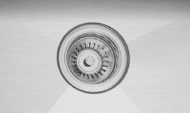

03/ 10mm Radius Corners with 230mm Depth
· Easy cleaning with no hidden dirt at corners
· Fit bigger pots and pans while minimise splashing
